UPPWISE INDIA

www.uppwise.com



**Quaterly Development Planning**

**Q1-2024**

**Feature: Resource Explorer Implementation**

**Feature Title:**

Resource Explorer Implementation

**Priority:**

Medium

**Submitted By:**

SPM

**Target Users:**

Resource Manager/Department Manager/General User

**Feature Description:**

The Resource Explorer is a comprehensive tool designed to facilitate efficient management and exploration of resources within a system or platform. It serves as a centralized hub for users to navigate, analyze, and take actions related to various resources.

**Acceptance Criteria:**

**Accessing Resource Explorer:**

* System verifies user permissions (Read/Write) for Resource Explorer under the role configuration.

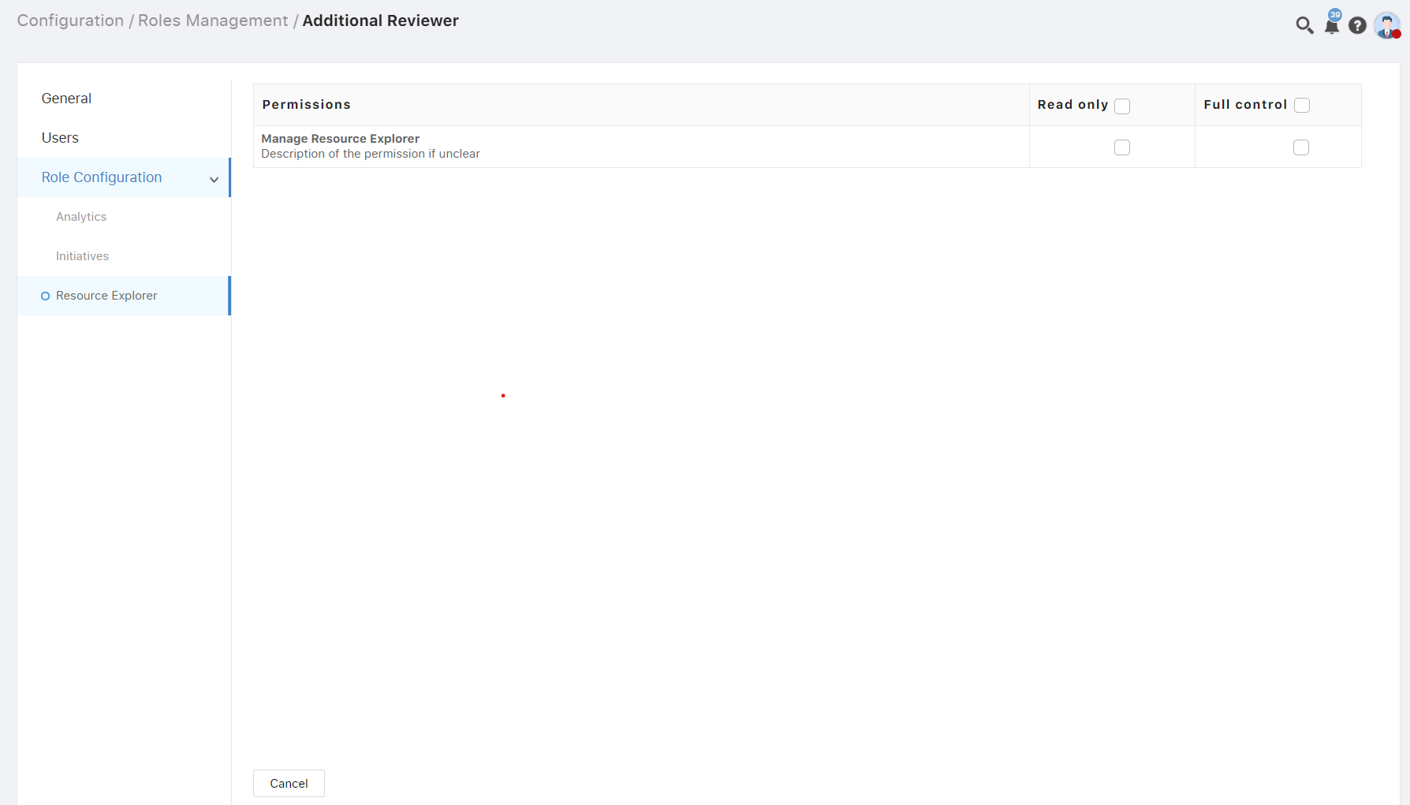

**Based on permission RE accessibility:**

1. **Administrator user:** Admin users have full access of the RE workspace. The RE menu will be visible to Admin user without providing RE permission.
2. **Department Manager:** A user who is assigned as a department manager for any department will be a Department Manager.
   1. To access the RE workspace user should have Resource Explorer permission either read or write permission.
   2. This user can view only resources belonging to its department resources and its child department resources.
3. **General User:** A user who is neither an Admin nor a department user but has the RE permission (read or write) can be access.
   1. To access the RE workspace user should have Resource Explorer permission either read or write permission.
   2. This user can view only resources belonging to its COS node and its child COS nodes resources.

**Menu Enable:**

* User accesses the Resource Explorer module from the navigation bar through the menu icon named as “Explorer or RE”.



**RE Workspace Layout:**

In this phase of development, we have fixed layouts which can be rename and manage the visibility by Layout creating layout popup. With the bellow conditions.

1. A layout can contain one widget only. Multiple widgets are not allowed in one layout.
2. In the workspace there will be at least one layout exists.

**Project Assignment View:**

* **User Interface:** Upon landing on the Project Assignment View, the system loads project data.
* **Display Details:** Project details are presented hierarchically, with resource data displayed under each project.
* **Effort Calculation:** The system calculates and presents total efforts based on Baseline, Actual, and Forecast data.
* **Filtering Options:** Users can refine the view using filters for Project, Resource, State, Portfolio, Program, and Department.
* **Permissions:** Resources are visible according to the user's permission level and the hierarchical structure.

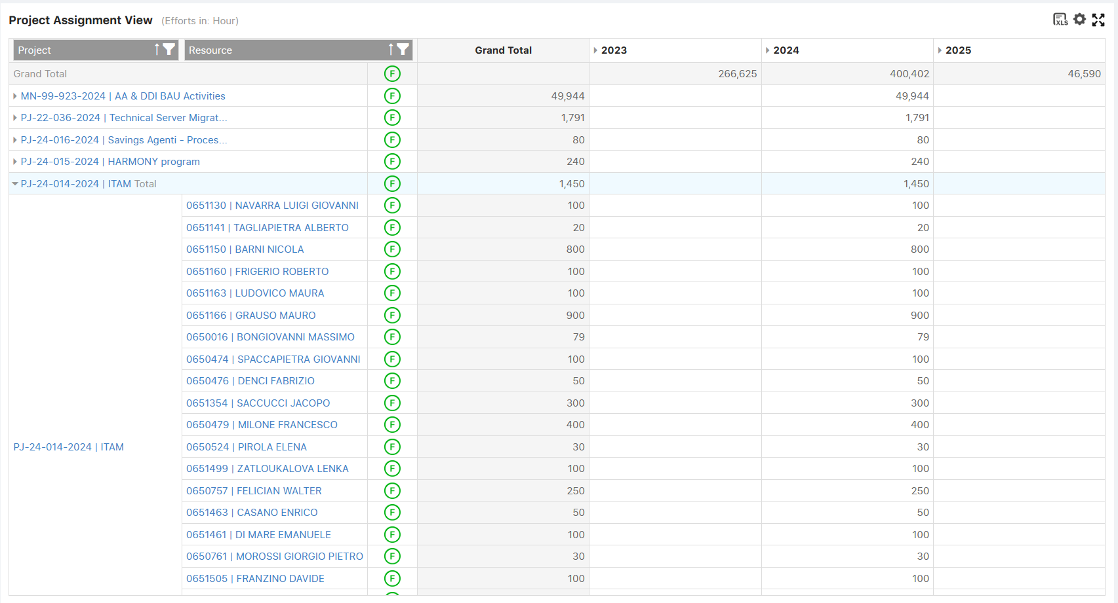

**Resource Assignment View:**

* **User Interface:** Upon accessing the Resource Assignment View, resource data loads with allocated projects displayed.
* **Effort Representation:** Efforts are represented in terms of Baseline, Actual, and Forecast for each resource.
* **Resource Information:** Resource details, including start date and finish date of the project, are displayed alongside the project allocation within the same pivot widget.
* Resource Assignment view will be visualizing the data in the read-only form for the resources with it’s associated project.

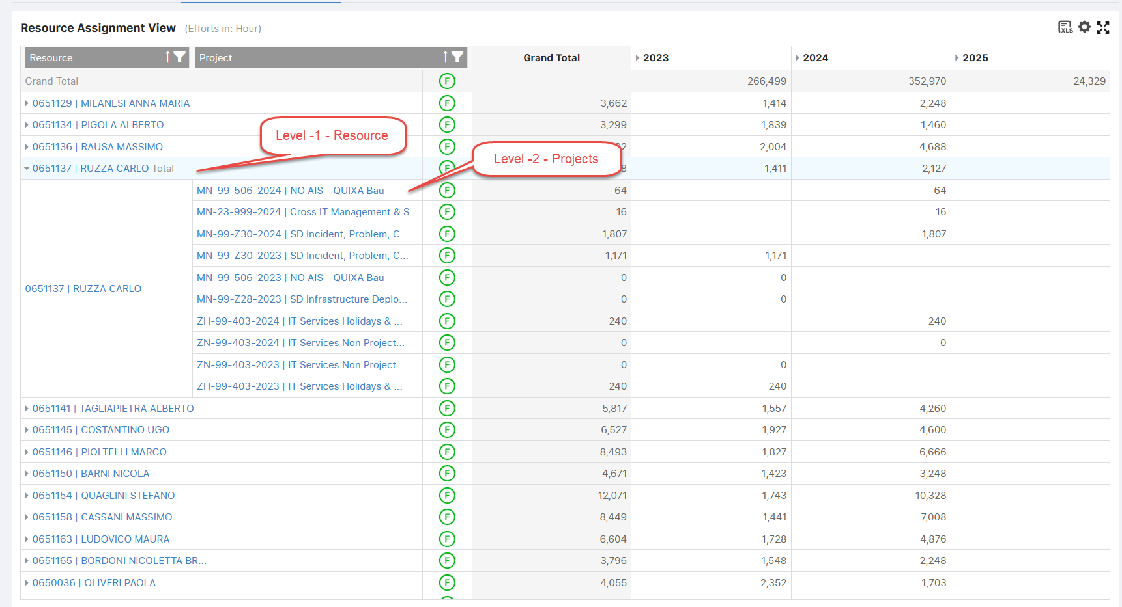

**Period Settings:**

* User sets the period (e.g., Year to date, this year, last year, specific period).
* Optionally limits the number of visible years for performance improvement.

**Project Team Building Widget (PTB)**:

* **Placement:** The "Project Team Building" widget is positioned below both the Project Assignment View and the Resource Assignment View, presented in a tab format adhering to the SPM standard. Project details will show in the header of the PTB widget.
* **Dynamic Updates**: The widget dynamically updates based on the selected project, displaying resource-based data relevant to that project. It utilizes the same capacity widget and provides the option to switch between automatic and manual modes for editing.
* **Custom Settings:** Custom settings are available within the widget, offering all necessary options for personalized configurations.
* **Functionality:** The widget encompasses various functionalities including resource assignment, replacement, deletion, and editing capabilities, empowering users with comprehensive control over project team management.

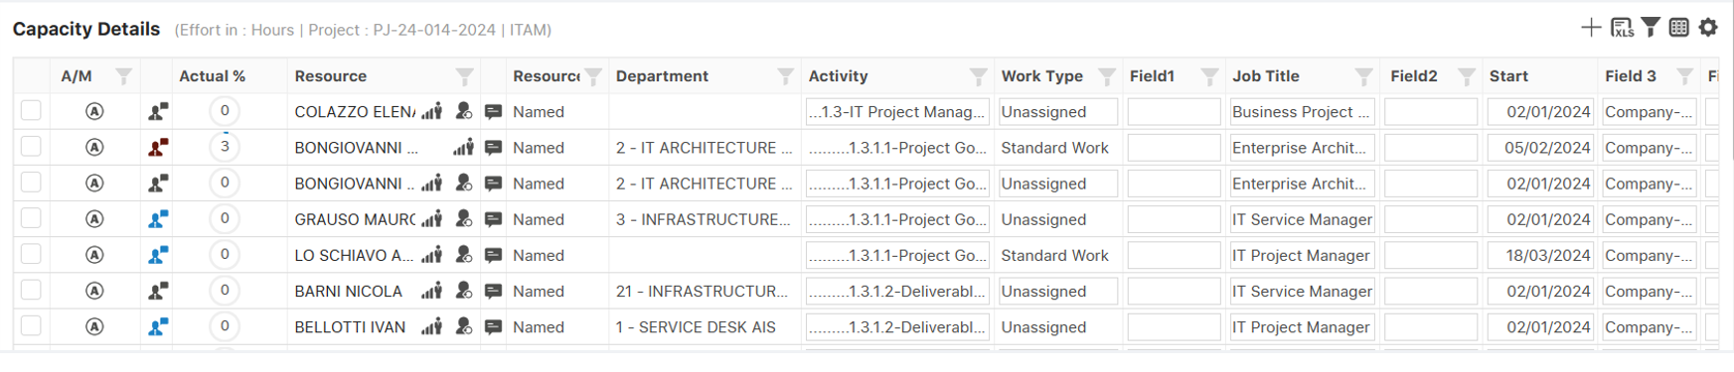

**Edit Resource View Widget (ERV)**:

* **Display of Allocated Projects:** Upon selecting a resource, the ERV displays a list of allocated projects for that resource based on assignment.
* **Dynamic Updates:** The widget dynamically updates based on the selected resource, presenting resource-based data accordingly. It utilizes the same capacity widget and provides the option to switch between automatic and manual modes for editing records.
* **Custom Settings:** Custom settings are available within the widget, offering all necessary options for personalized configurations, ensuring flexibility and adaptability to user preferences and project requirements.

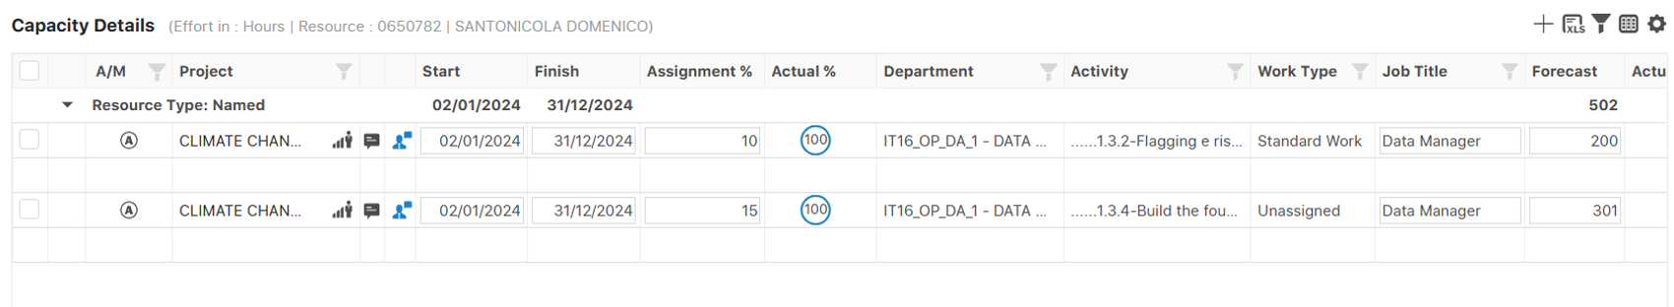

**Availability View:**

* Resource Availability view will be visualizing the resource data/Chart based on the selected group by from the customize view.
* In this view, the manager can observe a list of resource names alongside their availability, categorized based on Forecast (Work), Availability (Baseline), and Net Availability (Actual).
* The colors (Green, Orange, Red) signify and depict the net availability effort row. Orange indicates when there's no work and availability, Green highlights when availability exceeds work, and Red highlights when availability falls short of work.
* Clicking on a resource loads the ERV view, as described above.

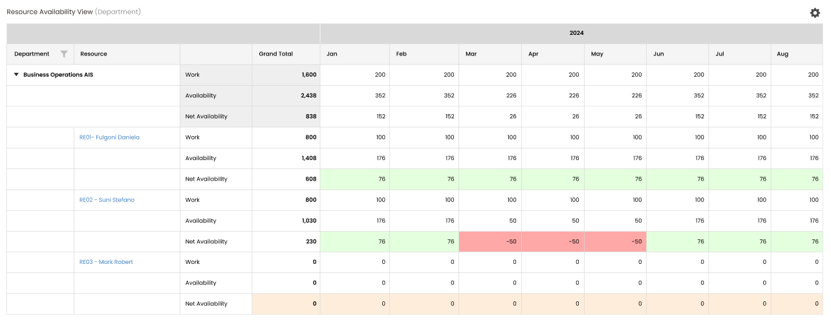

**Without Chart Representation**

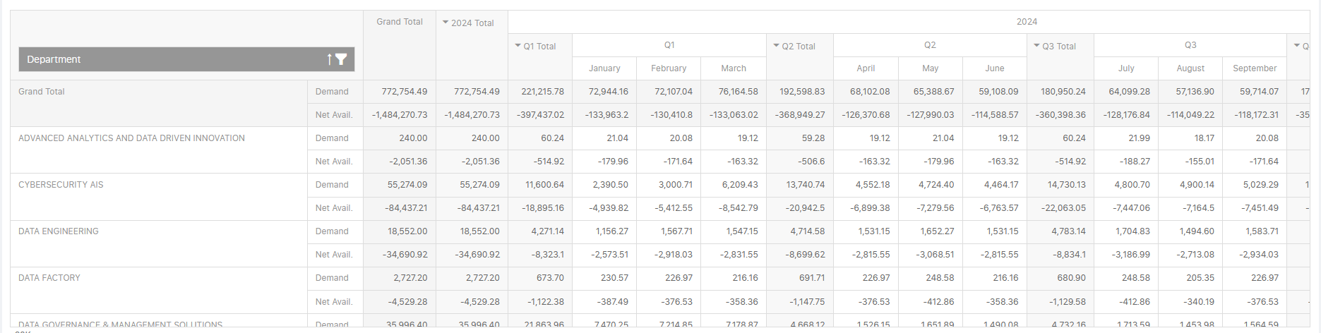

**Along with chart representation**

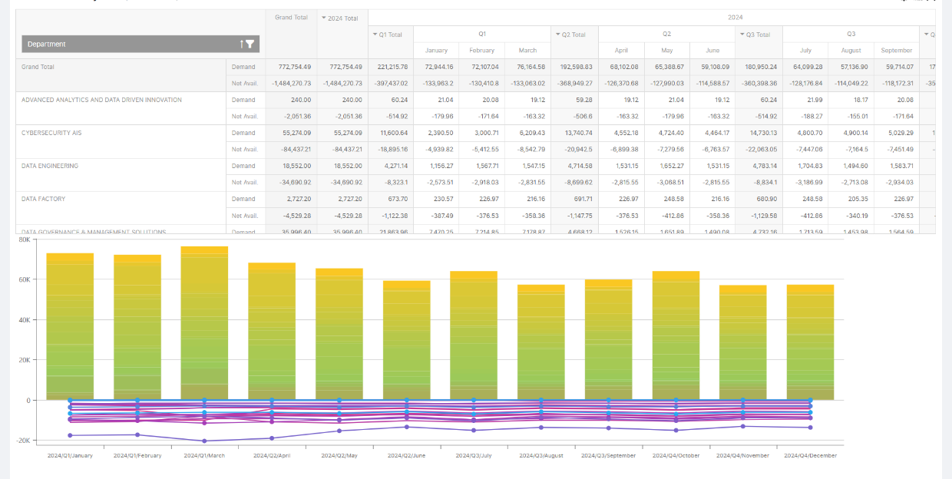

**Note:** This above screenshot is as per current implementation.

**COS Hierarchal view:**

This is a hierarchical view based on the COS. On expend of a COS node in the widget it’s show the hierarchy of the selected COS and show associated resources to the COS. For association of the resource and COS is available in the resource edit page. As shown in the bellow screenshot.

**Resource Edit for COS Association**

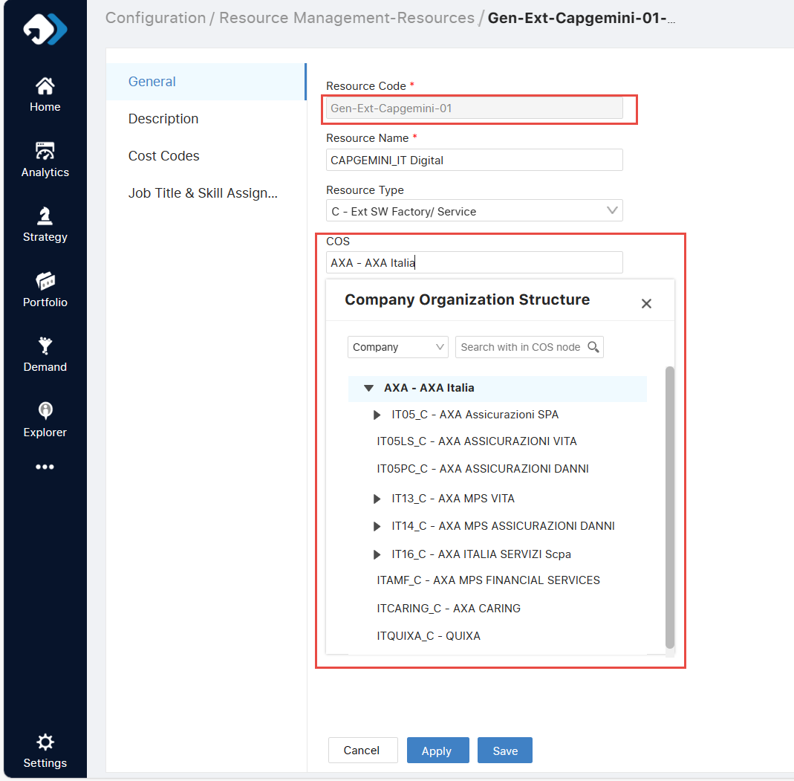

**COS Hierarchal View Widget**

